15U ENCLOSURE 19" CABINET 600X600 DATA RACK CABINET 15U FLOOR STANDING
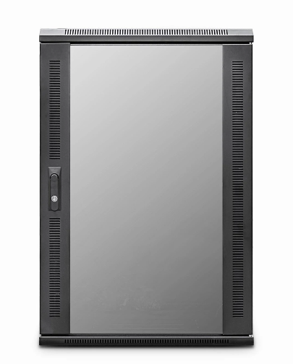

DESCRIPTION
Redefining Quality And Ergonomics In Small-Scale Network Deployment?
Looking to deploy a small height data or telco cabinet but need the
advantages of a full height cabinet?
The newly design EcoNetCab 12U and Rack Cabinet 15U floor-standing cabinets are ideal for
many installations that need all the advantages for full width, 19-inch racking,
full depth, adjustable mount posts and of course FREE, bundled cabinet accessories
including Fan Tray, vented shelf, castors and jacking feet for example.
With more networking, telco, PBX and broadcast equipment becoming more
compact and of course thinking all installations do not require a high,
towering 42U cabinet for example, the new EcoNetCab 12U and Rack Cabinet 15U floor-standing range are ideal for IT rooms, PBX switching centres, SME business applications, but without the
extra height clearance that other models need.
Superb-build quality of course is assured, multiple cable entries, together
with left/right hinged safety-glass door as standard, together with a hard-wearing
black, powder-coated finish and assembled here in the UK..

SPECIFICATIONS
- 15U high 600W 600D
- ETSI 19” front/rear profiles, adjustable
- Lockable vented glass door, reversible
- Removable side panels, rear lockable door
- Ideal for SME, IT Rooms, PBX & Broadcast
- 2-Way Low Noise Fan Tray Fitted
- Fitted Vented Shelf, Jacking Feet/Castors (4)
- UK Assembled and quality assured

TECHNICAL INFO

SKU/MPN: CAB-FE-15U-66
EAN: 8400800034632
Weight: 50kg
Dimensions: 600(width) x600(depth) x860mm(height)

FILES
Datasheet - CAB-FE-15U-66

